I assumed that every person who have unity installed on computer, knows how to import project, so i only described how to run simulation without unity.

1. Copy „simulation” folder on you computer
2. Run Inżynier.exe
3. You should see main menu

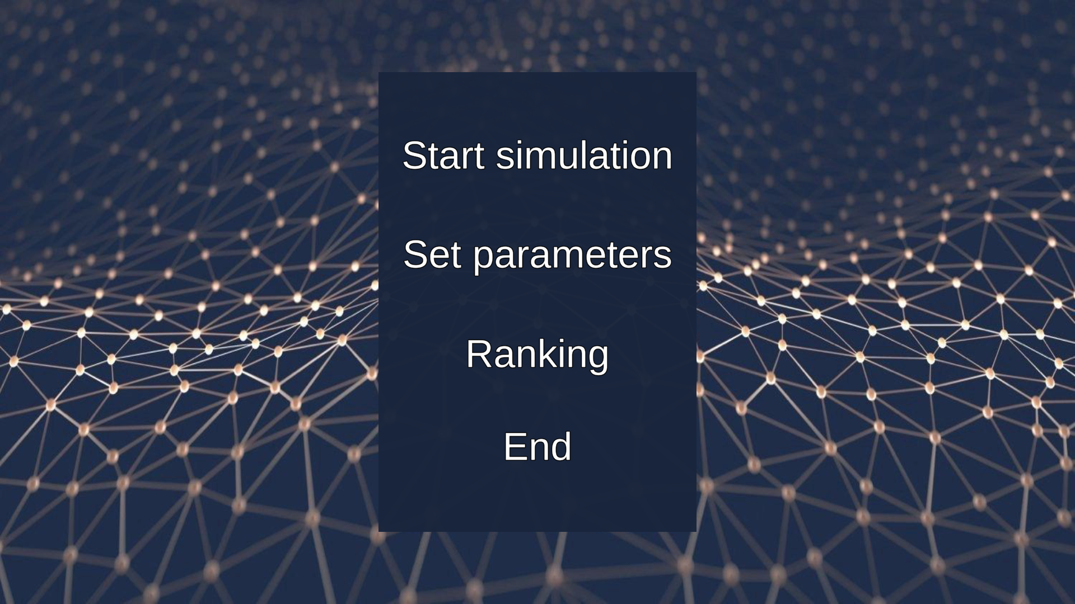

Simulation does not require you set parameteres before starting. Program sets parameters in background with default values, so it is ready to lunch.

After starting you will see screen with simulation.

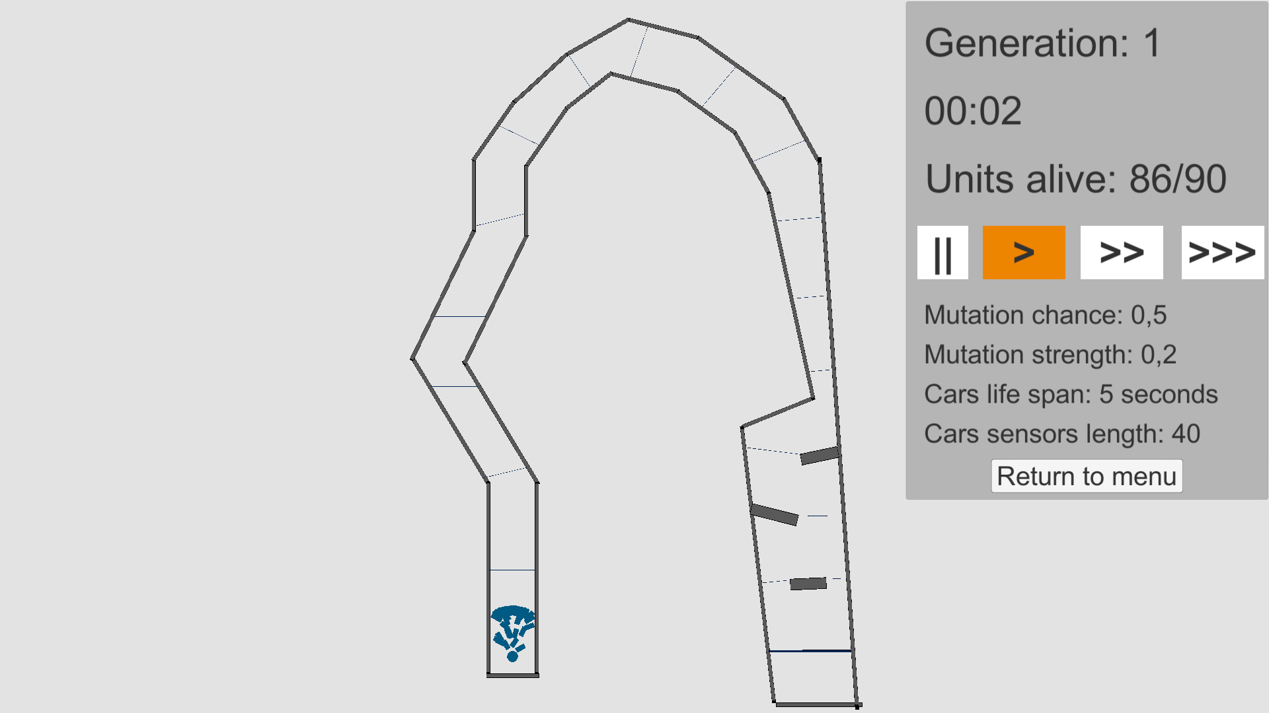

Blue rectangles are models representing cars. Each car fas five sensors which are invisible in game mode. Each of them calculate distance from car to track boundaries.

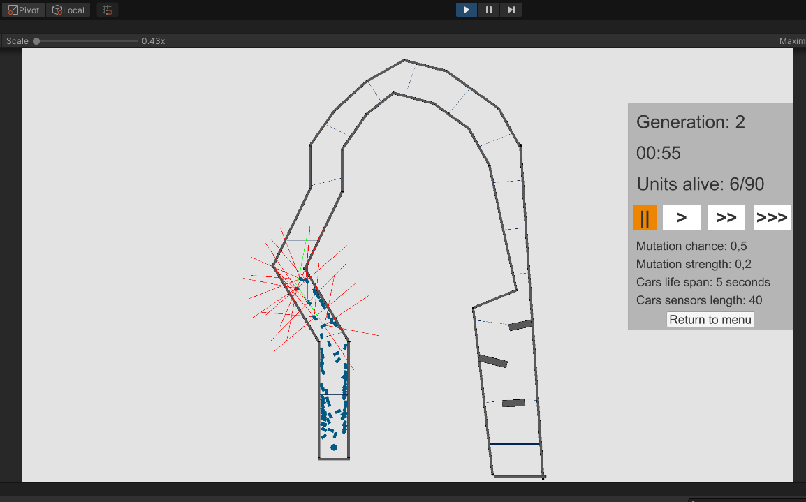

Figure 1 screen from unity debug mode

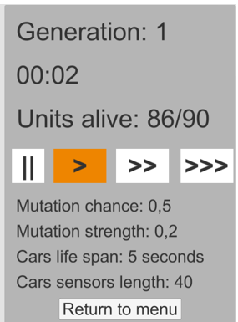

This panel is gui. It enables you to control time by buttons

* || *(stop)*
* > *(normal speed)*
* >> *(3x speed)*
* >>> *(5x speed)*

You can break simulation by returing to main menu button.

It also shows

* number of generation,
* time duration of simulation,
* how many unit are ‘alive’ at a time
* simulation parameters

After simulation you will see this screen with a summary of all parameters.

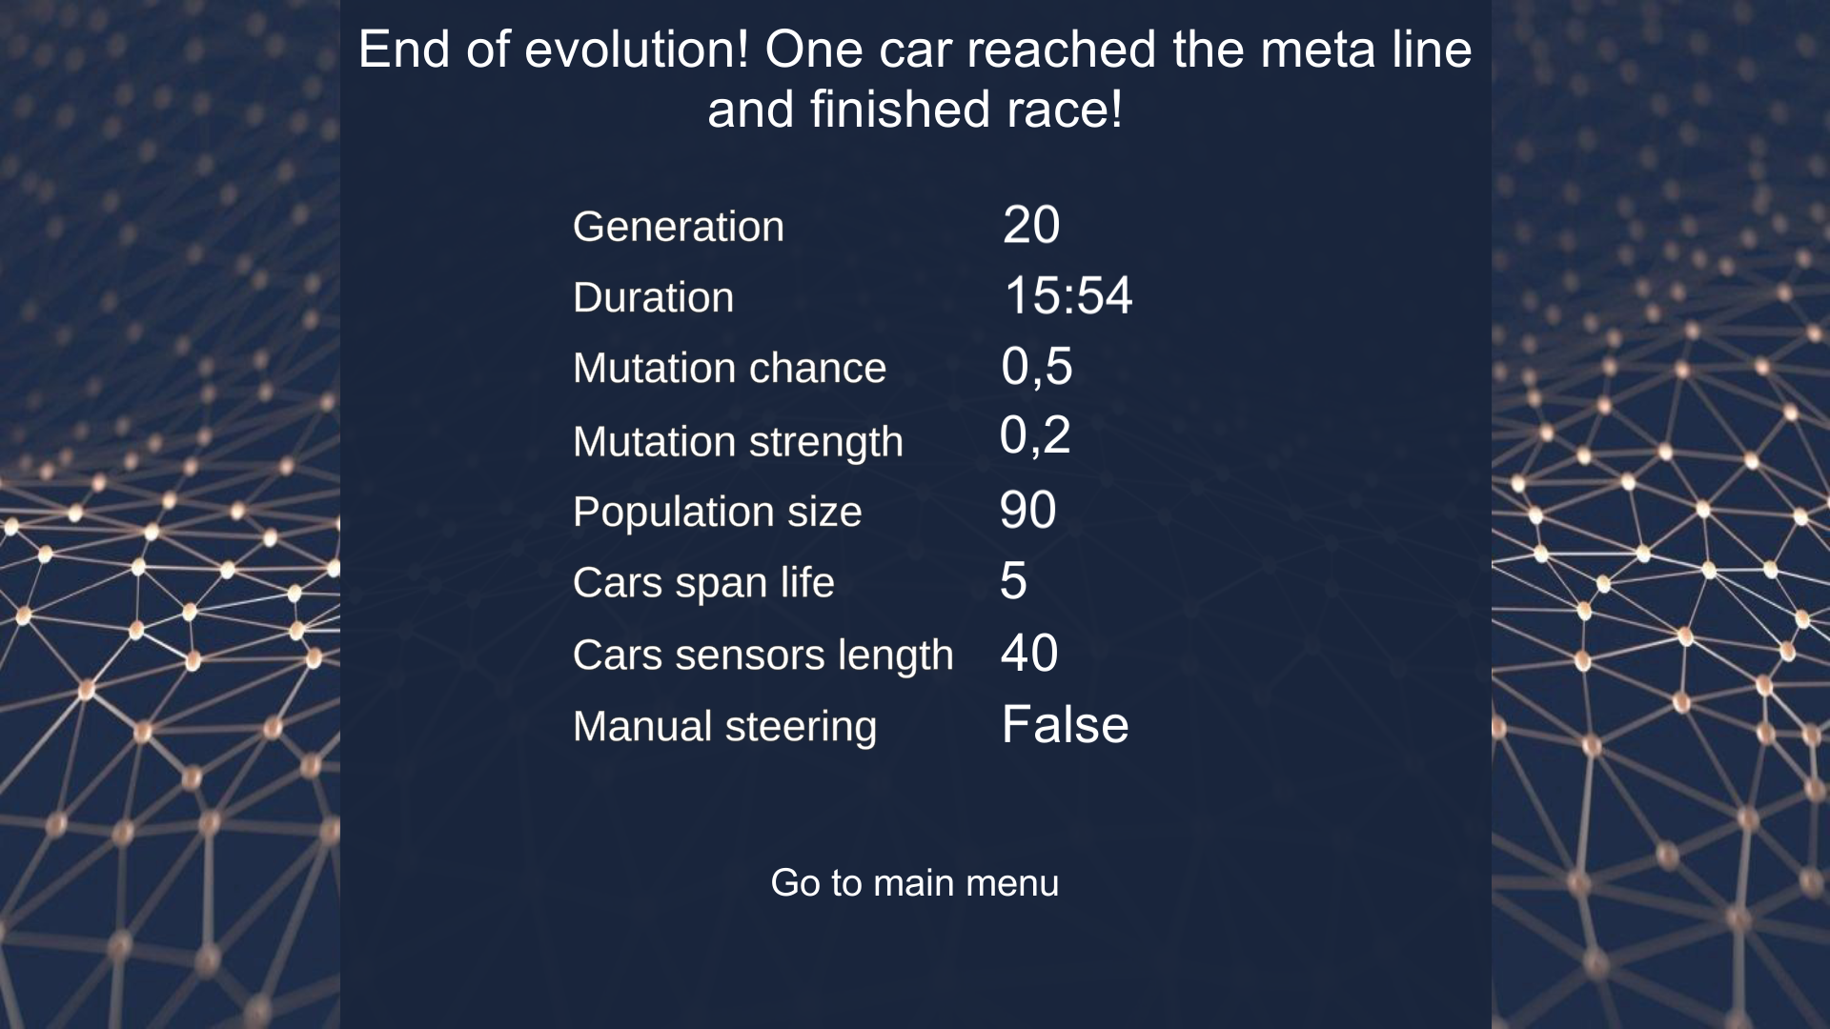

Additionally, they will be saved to the file „score.txt”. If you

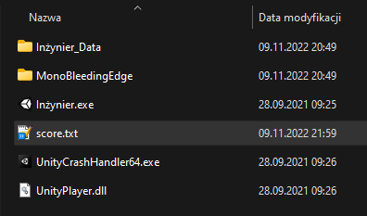

Ranking uses this file. It shows record sortered by generation number. If you delete a file don't worry, program will create it once again when it ends simulation.

Short description of parameters:

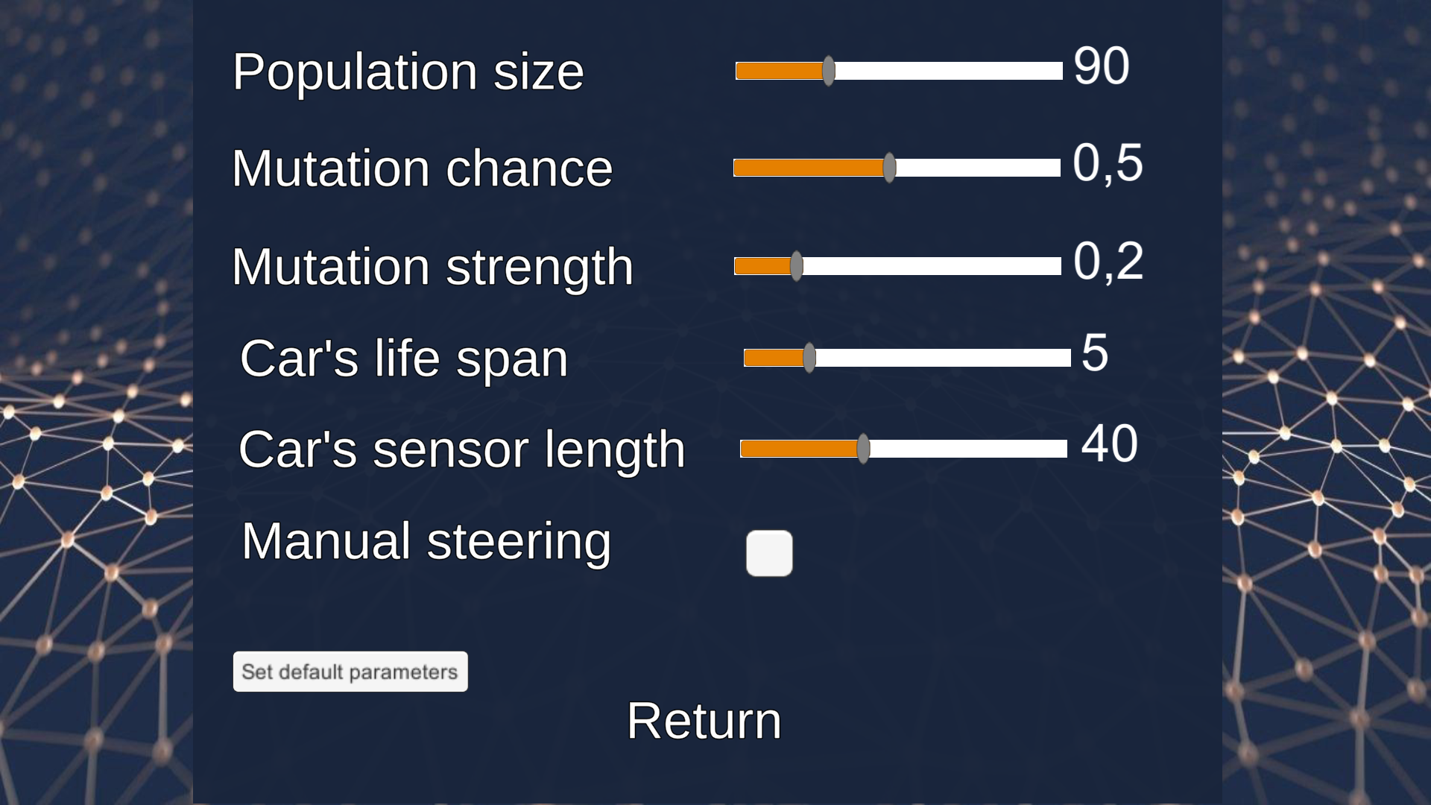

* Population size – how many cars are in simulation
* Mutation Chance – it represent probability of mutation occurs
* Mutation strength – it represent how big impact **may** have mutation when occur
* Car’s life span – every car has some amount of time to get to next checkpoint. If it fails, it will be deactivated
* Car’s sensor length – how long sensors are
* Manual steering – It enables to control car by yourself